
Dashboard Design

Date | 25 August 2026
Team ID | xxxxxx
Project Name | India’s agricultural crop production analysis (1997-2021)
Maximum Marks | 5 Marks

Activity 1: Interactive and visually appealing dashboards
The dashboard “Agricultural Production Insights” presents an interactive analysis of India’s agricultural crop production from 1997-2021.It combines maps, bar charts, line charts, and pie charts to provide insights into production trends cultivated area, stat-wise production, and seasonal production. Filters for year, state, season, and crop allow users to explore the data interactively and compare different aspects of agricultural production.
Checklist-
- Clear and Intuitive lay ought
- Use Appropriate Visualizations
- Colours and Theming
- Interactive filters and slicers
- Responsive Design
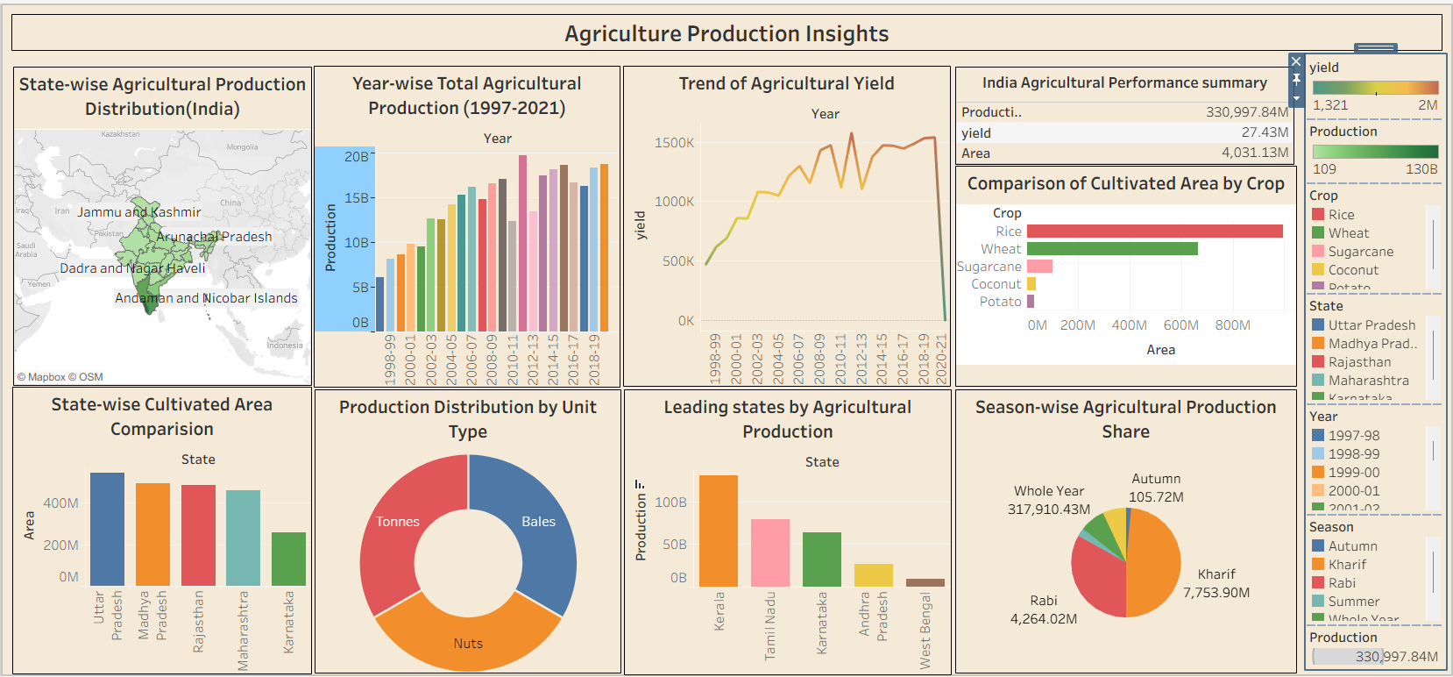
Activity 2
Publish Dashboard on Tableau Public and Paste the Dashboard Public link below:
Example
https://public.tableau.com/views/Book1_17878090788950/Dashboard1?:language=en-US&publish=yes&:sid=&:redirect=auth&:display_count=n&:origin=viz_share_link

